**Day 08**

**Group Administration**

**Creating Group :** Group Administration Create groups using groupadd.

**Modifying Group:** They Can change group attributes such as group name or Gid using groupmod.

**Deleting Group:**unnecessary groups can be removed using groupdel.

**1.Create the Group and Views**

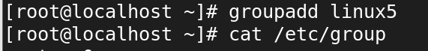

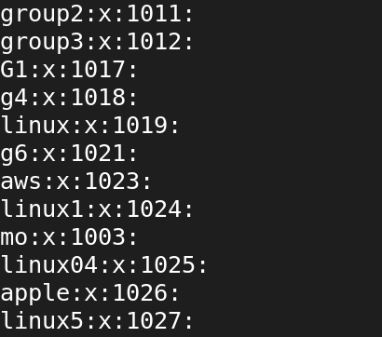

**2.useradd and adding user to group**

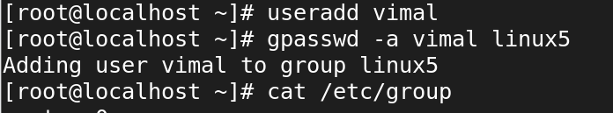

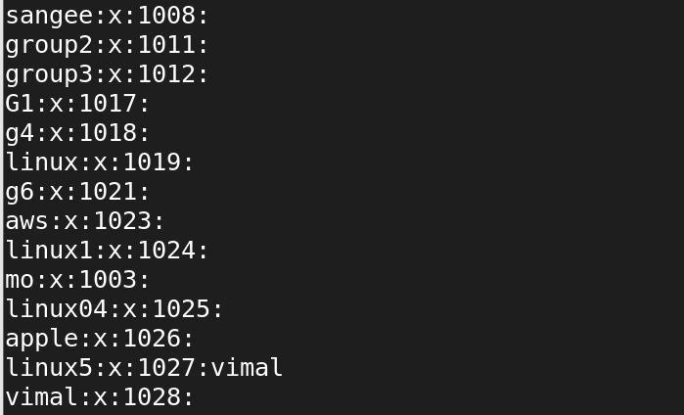

**3.Group has been Deleting**

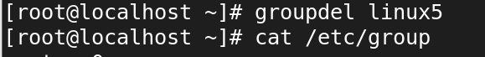

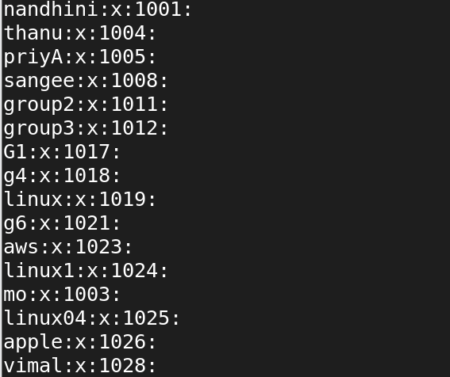

**5.User or Own has been Changed**

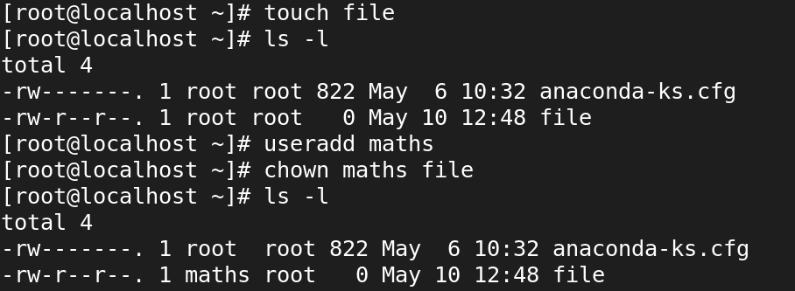

**6.Group has been Changed**

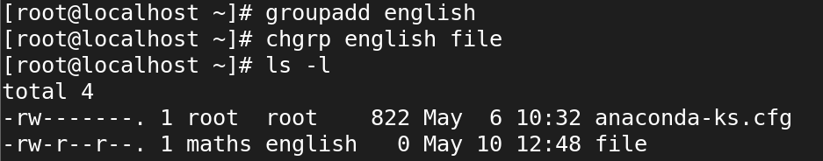

**7.Overall Change to own,group**

